21CSS303T/DATA SCIENCE PROJECT REPORT
Submitted by
KALAVALA SHIVA HARI KOWSHIK – RA2311026050144.
Under the guidance of
Dr. CHITRADEVI D
(Associate Professor, School of Computing)
in partial fulfilment for the award of the degree
of
BACHELOR OF TECHNOLOGY
in
COMPUTER SCIENCE AND ENGINEERING WITH SPECIALIZATION OF ARTIFICIAL INTELLIGENCE AND MACHINE LEARNING
Of
FACULTY OF ENGINEERING AND TECHNOLOGY

SRM INSTITUTE OF SCIENCE AND TECHNOLOGY, TIRUCHIRAPPALLI
MAY 2026

SRM INSTITUTE OF SCIENCE AND TECHNOLOGY
(Deemed to be University U/S3ofUGCAct,1956)

BONAFIDE CERTIFICATE

Certified that this project report titled FAKE NEWS DETECTION SYSTEM USING MACHINE LEARNING Is the Bonafide work of….], who carried out the project work under my supervision. Certified further, that to the best of my knowledge the work reported herein does not form any other project report or dissertation on the basis of which a degree or award was conferred on an occasion on this or any other candidate.

SIGNATURE  Dr. CHITRADEVI D M.E., Ph.D.,  Associate Professor  School of Computing,  SRM Institute of Science and Technology,  Tiruchirappalli. | SIGNATURE  Dr. R. Balaji Ganesh, M. Tech., Ph.D., Postdoc  Head of the Department  Department of Computer Science and Technology with Specialization in Artificial Intelligence and Machine Learning,  School of Computing  SRM Institute of Science and Technology,  Tiruchirappalli.

Submitted for the project viva-voce held on [Date] at SRM Institute of Science and Technology, Tiruchirappalli.

SRM INSTITUTE OF SCIENCE AND TECHNOLOGY
TIRUCHIRAPPALLI

DECLARATION

We hereby declare that the entire work contained in this project report titled FAKE NEWS DETECTION SYSTEM USING MACHINE LEARNING has been carried out by ….. at SRM Institute of Science and Technology, Tiruchirappalli, under the guidance of Dr. CHITRADEVI D, Associate Professor, School of Computing.

Place: Tiruchirappalli
Date: [Date]
ABSTRACT
The proliferation of digitally disseminated misinformation has emerged as a critical challenge for contemporary society, undermining public discourse, influencing electoral processes, and eroding trust in legitimate journalistic institutions. Traditional approaches to fake news detection, which rely predominantly on manual fact-checking and editorial oversight, are demonstrably insufficient to address the scale and velocity of misinformation propagation across modern digital platforms. This project presents a full-stack machine learning system for automated fake news detection, designed to deliver rapid, interpretable, and multi-model classification of news content.
The proposed system integrates a classical natural language processing pipeline, comprising Term Frequency–Inverse Document Frequency (TF-IDF) vectorization for text representation, with an ensemble of four independently trained supervised classifiers: Logistic Regression, Decision Tree, Gradient Boosting, and Random Forest. The backend inference engine is implemented as a RESTful API using the Flask microframework, while the frontend user interface is built with React and the Vite build toolchain. Preprocessing operations, including lowercasing, punctuation and URL removal, HTML tag stripping, and digit normalization, are applied consistently at inference time to align with training-time feature distributions.
The system architecture emphasizes model diversity and transparency, presenting per-model classification outputs alongside a consensus signal that quantifies inter-model agreement. Special attention is given to user experience features such as real-time debounced prediction, persistent prediction history, dark mode theming, and clipboard integration. Evaluation of the system demonstrates that the multi-model approach provides richer diagnostic information than any single classifier, enabling users to assess prediction confidence through model consensus. The report discusses the system's architecture, implementation details, performance characteristics, limitations, and directions for future enhancement toward production-grade deployment.

TABLE OF CONTENTS

CHAPTER NO. TITLE PAGE NO.
ABSTRACT iv
LIST OF FIGURES vi
LIST OF ABBREVIATIONS vii

1 INTRODUCTION 8
1.1 Introduction 8
1.2 Problem Statement 9
1.3 Objectives 10
1.4 Scope and Motivation 11

2 EXISTING SYSTEM 13
3 PROPOSED METHODOLOGY 16
4 IMPLEMENTATION 19
5 RESULT AND DISCUSSION 25
6 CONCLUSION 30
REFERENCES 32
PUBLICATION/PRESENTATION PROOF 26

LIST OF FIGURES

FIGURE NO. | TITLE | PAGE NO.
2.1 | System architecture | 16
4.7.1 | Dashboard.py | 22
4.7.2 | Agent chat View.py | 22
4.7.3 | KPI Panel.py | 23
4.7.4 | Procurement.py | 24
4.7.5 | Risk Panel.py | 25
4.7.6 | Shipment Map.py | 25
5.1.1 | Control Tower Dashboard | 26
5.1.2 | Risk Monitoring Dashboard | 26
5.1.3 | Agent Activity Dashboard | 27
5.1.4 | Procurement Dashboard | 27
5.1.5 | Supply Chain Data Science Dashboard | 28

LIST OF ABBREVIATIONS

S. No. | Abbreviation | Expansion
1 | ML | Machine Learning
2 | NLP | Natural Language Processing
3 | TF-IDF | Term Frequency – Inverse Document Frequency
4 | LR | Logistic Regression
5 | DT | Decision Tree
6 | GB | Gradient Boosting
7 | RF | Random Forest
8 | API | Application Programming Interface
9 | REST | Representational State Transfer
10 | JSON | JavaScript Object Notation
11 | UI | User Interface
12 | SPA | Single Page Application
13 | CORS | Cross-Origin Resource Sharing
14 | WSGI | Web Server Gateway Interface
15 | SHAP | SHapley Additive exPlanations
16 | LIME | Local Interpretable Model-agnostic Explanations
17 | HTML | HyperText Markup Language
18 | URL | Uniform Resource Locator
19 | CPU | Central Processing Unit
20 | ROC-AUC | Receiver Operating Characteristic – Area Under Curve

1. INTRODUCTION

1.1 Introduction
The emergence of social media and online news aggregation platforms has fundamentally transformed the manner in which information is consumed and disseminated globally. While this democratization of information access has yielded considerable societal benefits, it has simultaneously created fertile conditions for the propagation of misinformation and disinformation at unprecedented scale and speed. Fake news, broadly defined as fabricated or deliberately misleading content presented with the visual and structural conventions of legitimate journalism, represents one of the most consequential threats to informed public discourse in the modern digital age.
Machine learning-based approaches to fake news detection have attracted substantial research attention over the past decade, primarily because they offer the potential to automate classification at a scale that is impossible for human fact-checkers. Among these approaches, classical text classification pipelines that combine lexical feature extraction techniques such as TF-IDF vectorization with supervised classifiers such as Logistic Regression, Decision Trees, Random Forests, and Gradient Boosting have demonstrated consistently strong performance on benchmark datasets, often rivalling more computationally expensive deep learning architectures while remaining interpretable and deployable on modest hardware.
This project implements a fully operational inference-time fake news detection system that integrates these classical machine learning methods into a production-oriented full-stack application. The system couples a Flask-based REST API backend, which handles preprocessing and multi-model inference, with a modern React frontend that provides real-time user interaction, model-level transparency, and persistent prediction history. By presenting users with four independent model predictions and a consensus signal, the system goes beyond conventional single-label classification, offering a richer picture of uncertainty and inter-model agreement that is particularly valuable for borderline or ambiguous news content.

1.2 Problem Statement
The global information ecosystem is increasingly compromised by the deliberate fabrication and viral dissemination of false or misleading news content. Fake news exploits the cognitive tendencies of human readers, employing emotionally charged time dashboard is language, sensationalist headlines, and superficial journalistic conventions to achieve credibility and rapid spread. The consequences of such misinformation are wide-ranging, encompassing public health crises exacerbated by medical misinformation, electoral integrity undermined by targeted disinformation campaigns, and the general erosion of trust in established media institutions.
Existing fact-checking mechanisms are primarily manual, dependent on teams of journalists and domain experts who evaluate claims against verifiable evidence. This approach, while reliable for well-resourced cases, is fundamentally unable to scale to the volume of content generated daily across digital platforms. Automated fake news detection systems are therefore a critical technological necessity. However, many proposed solutions in the research literature remain confined to experimental contexts, lacking the engineering infrastructure required for practical deployment and user-facing application.
Furthermore, a significant limitation of single-classifier systems is that they provide a binary verdict without communicating any measure of prediction uncertainty or inter-model disagreement. This opacity is problematic in high-stakes contexts where decision-makers require not just a classification label but also an indication of system confidence. The absence of transparent, multi-model inference systems that are simultaneously accessible to non-technical users represents a meaningful gap in current applied fake news detection tooling, which this project seeks to address.

1.3 Objectives
The primary objective of this project is to design, implement, and deploy a full-stack machine learning system capable of classifying news content as either genuine or potentially fabricated, with the outputs of four independent supervised classifiers presented simultaneously to the user. This multi-model transparency approach is intended to provide richer diagnostic information than a single classifier, enabling assessment of prediction confidence through the lens of inter-model consensus.
A secondary objective is the implementation of a robust text preprocessing pipeline that faithfully replicates the normalization steps applied during model training. This preprocessing parity is critical to ensuring that inference-time feature vectors are drawn from the same distribution as training-time vectors, thereby preserving the predictive validity of the pre-trained model artifacts. The pipeline includes lowercasing, removal of bracketed content, stripping of non-word characters, URL removal, HTML tag elimination, punctuation removal, and digit normalization.
The project further aims to deliver a user-facing web application that is simultaneously functional, aesthetically polished, and informationally rich. The frontend must expose per-model classification results, a consensus count, a persistent prediction history with reload capability, dark mode theming, and real-time debounced inference. Through this combination of engineering and user experience objectives, the project aspires to demonstrate that serious machine learning applications need not sacrifice accessibility or transparency in the interest of technical sophistication.

1.4 Scope and Motivation
The scope of this project is explicitly delimited to the inference-time serving of pre-trained machine learning models for fake news classification. The training pipeline, dataset curation, and model evaluation phases are treated as prior work, with their outputs — a set of serialized Pickle artifacts for the TF-IDF vectorizer and four classifiers — constituting the fixed inputs to the serving system. Within this scope, the project encompasses the full-stack engineering of a backend API and a frontend interface, along with the design and analysis of the text preprocessing pipeline and the system integration connecting these components.
The motivation for this project is grounded in both the practical urgency of misinformation detection as a societal challenge and the technical opportunity afforded by classical machine learning methods. Despite the widespread availability of large language models and transformer-based classifiers, classical TF-IDF combined with ensemble classifiers remains a highly practical choice for deployed systems due to its low computational overhead, deterministic inference, and interpretability. This project demonstrates that these well-understood methods, when integrated into a carefully engineered full-stack application, can deliver meaningful value in real-world contexts.
Moreover, the multi-model architecture of this system reflects a commitment to epistemic humility — the recognition that no single classifier is infallible, and that the communication of model disagreement is itself a form of transparency that serves users well. This philosophical stance, combined with the concrete engineering accomplishments of the project, positions it as a meaningful contribution both to applied machine learning practice and to the ongoing effort to develop tools that help societies navigate an increasingly complex information environment.

2. EXISTING SYSTEM
The landscape of automated fake news detection is populated by a diverse array of approaches, ranging from content-based machine learning systems to knowledge graph-based fact verification engines and crowdsourced credibility scoring platforms. Understanding the characteristics, strengths, and limitations of these existing systems is essential to contextualizing the design decisions made in the proposed project and situating its contributions within the broader research and engineering ecosystem.
Early work in automated misinformation detection focused on stylometric and linguistic feature engineering, extracting hand-crafted features such as syntactic complexity, subjectivity scores, writing style markers, and lexical diversity measures from news text. Classifiers trained on these features, including Support Vector Machines and Naive Bayes models, achieved moderate accuracy on curated datasets but were highly sensitive to domain shift and required substantial feature engineering expertise. Systems such as the LIAR dataset benchmark classifiers and early FakeNewsNet evaluation frameworks represent this generation of approaches.
The subsequent generation of fake news detection systems leveraged dense word embedding representations, particularly Word2Vec and GloVe, which enabled classifiers to capture semantic relationships between terms rather than relying purely on lexical statistics. These representations were typically fed into conventional classifiers or shallow neural architectures. While they offered improved generalization over pure TF-IDF approaches in some domains, they introduced significantly higher computational and memory requirements at both training and inference time, complicating deployment in resource-constrained environments.
More recently, transformer-based models such as BERT, RoBERTa, and their domain-adapted variants have established new state-of-the-art benchmarks on fake news classification tasks. These models, which were pre-trained on large corpora using self-supervised objectives, capture deep contextual dependencies and have demonstrated remarkable transfer learning capabilities. However, their inference latency, memory footprint, and fine-tuning data requirements represent substantial practical barriers to deployment, particularly for lightweight or locally hosted applications.
Knowledge-based verification systems, such as those employing entity linking against fact databases like Wikidata or DBpedia, represent an orthogonal paradigm that cross-references factual claims against structured knowledge repositories. These systems are capable of producing highly specific, evidence-grounded assessments but are limited to claims for which structured factual evidence exists. They perform poorly on opinion-laden content, emerging news events not yet represented in knowledge bases, and content that relies on implicit rather than explicit factual assertions.
Crowdsourced and reputation-based systems, including platforms such as Snopes, PolitiFact, and FactCheck.org, leverage human expertise and community consensus to evaluate news credibility. While these platforms provide high-quality assessments, their throughput is fundamentally constrained by the availability of human reviewers, making them unsuitable for real-time or high-volume classification tasks. Hybrid systems that combine automated classification with human-in-the-loop verification offer a promising middle ground but introduce additional architectural complexity.
The primary limitation shared by the majority of existing research-focused systems is the gap between experimental performance metrics and production deployment readiness. Most systems are evaluated on fixed, well-curated benchmark datasets under idealized conditions, without addressing the engineering challenges of real-time serving, user interface design, input validation, error handling, or the critical importance of preprocessing parity between training and inference. The proposed system distinguishes itself by prioritizing these engineering dimensions alongside model quality, delivering a fully integrated application with appropriate attention to both technical rigor and user accessibility.

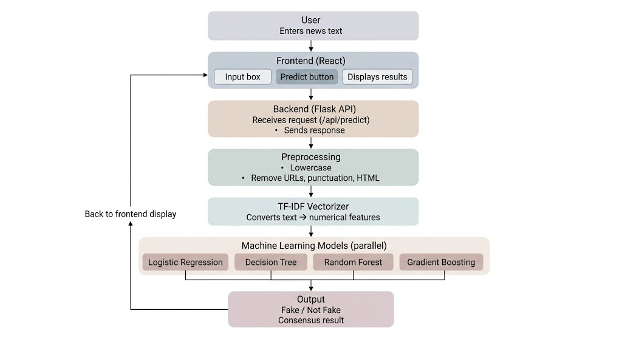

Figure 2.1. SYSTEM ARCHITECTURE

3. PROPOSED METHODOLOGY
The proposed methodology for the fake news detection system is structured as a six-stage pipeline that progresses from raw user input through systematic text normalization, feature engineering, multi-model inference, and finally to result synthesis and presentation. Each stage is designed to ensure both technical correctness and operational efficiency, with particular emphasis on the critical requirement that inference-time processing precisely mirrors the preprocessing applied during model training.

Step 1: User Input Collection
The process originates in the browser-based React frontend, where the user enters news text into a designated textarea component. The frontend accommodates both deliberate submission via a Predict button and automated inference triggered by a debounce mechanism that fires approximately one second after the user ceases typing, provided the input exceeds ten characters in length. This dual-trigger design balances responsiveness with economy of API calls, ensuring that users receive near-instantaneous feedback during extended text entry without imposing excessive load on the backend inference service.

Step 2: Text Preprocessing and Normalization
Upon receipt of the user's text at the backend, the wordopt preprocessing function is applied. This function implements a strict sequential normalization pipeline designed to reduce lexical noise and standardize the input feature space. The first operation is case folding, which converts all characters to lowercase to eliminate spurious differentiation between typographically varied occurrences of the same token. Subsequent operations remove bracketed content using a lazy wildcard regular expression, replace non-word characters with whitespace, strip URLs matching both http/https schemes and bare www prefixes, eliminate residual HTML-like tags, remove all punctuation characters defined in Python's string.punctuation, excise newline characters, and finally remove any alphanumeric tokens that contain at least one digit, thereby eliminating numeric identifiers, dates, and other digit-bearing tokens that tend to be idiosyncratic to specific news items.

Step 3: TF-IDF Feature Transformation
The normalized text string is passed to the pre-fitted TF-IDF vectorizer, loaded from its serialized Pickle artifact at application startup. The vectorizer applies the inverse document frequency weighting scheme learned during training to the token frequencies present in the cleaned input, producing a sparse numeric vector whose dimensionality corresponds to the vocabulary established during the training phase. This vector is the sole input to all four downstream classifiers, ensuring that each model operates on an identical feature representation and that any variation in their outputs reflects genuine differences in learned decision boundaries rather than differences in input representations.

Step 4: Multi-Model Inference
The TF-IDF feature vector is simultaneously passed to four independently trained scikit-learn classifiers: a Logistic Regression model (lr_model.pkl), a Decision Tree classifier (dt_model.pkl), a Gradient Boosting classifier (gb_model.pkl), and a Random Forest ensemble (rf_model.pkl). Each classifier applies its learned parameters to produce a binary class prediction, which is subsequently mapped from its internal integer encoding (0 for Fake News, 1 for Not A Fake News) to a human-readable string label. This fan-out inference pattern allows the system to simultaneously leverage the strengths of multiple model families — the linearity and probabilistic calibration of logistic regression, the non-linear partitioning of tree-based methods, and the ensemble stability of boosting and bagging approaches.

Step 5: Response Synthesis and API Return
The four labeled predictions are assembled into a structured JSON response object with keys corresponding to each model abbreviation (LR, DT, GB, RF). This response is returned to the frontend via the Flask API endpoint, which handles the HTTP response serialization and CORS configuration. The API's single-endpoint design keeps the contract between frontend and backend minimal and explicit, facilitating both debugging and future extensibility.

Step 6: Frontend Result Display and History Persistence
Upon receipt of the API response, the React frontend parses the JSON payload and renders each model's prediction in a visually structured result block. A consensus computation iterates over the four model outputs and counts the number of models that predicted Fake News, displaying the result as a fraction (e.g., 3/4 models detect Fake News). Successful predictions are also persisted to the browser's localStorage as history entries containing a truncated text preview and a timestamp-derived identifier, allowing users to review and reload previous queries. The overall system pipeline thus closes the loop from user input to transparent, multi-model classification output in a single, low-latency request-response cycle.

4. IMPLEMENTATION
The implementation of the fake news detection system is organized across two primary tiers — a Python-based backend inference service and a JavaScript-based frontend application — along with a set of pre-trained machine learning artifacts that constitute the model layer. The following subsections describe the development environment, the implementation of each system component, and the integration mechanisms that bind them into a coherent full-stack application.

4.1 Development Environment
The backend inference service is implemented in Python 3, utilizing the Flask microframework for HTTP request handling, scikit-learn for machine learning artifact loading and inference, and the standard library's re and string modules for text preprocessing. All Python dependencies are managed within a virtual environment (env/) to ensure reproducibility and isolation. The frontend application is developed using React 18 with Vite as the build toolchain and development server. Vite provides a highly optimized development experience with hot module replacement and a built-in proxy mechanism that allows the frontend to communicate with the backend without cross-origin request complications during development.
The development workflow utilizes the concurrently package to orchestrate simultaneous startup of both the frontend and backend development servers via a single npm run dev:all command. The wait-on utility is used to introduce a startup dependency, ensuring the backend service is reachable before the frontend development server attempts to proxy API requests. This configuration provides a streamlined local development experience without requiring Docker or other containerization infrastructure.

4.2 Backend / API Implementation
The Flask application is implemented in backend.py and constitutes the core inference engine of the system. At application startup, all five Pickle artifacts are deserialized from disk — the four classifier models (lr_model.pkl, dt_model.pkl, gb_model.pkl, rf_model.pkl) and the TF-IDF vectorizer (tfidf.pkl) — and stored as module-level variables. This eager-loading strategy avoids the latency cost of artifact deserialization on every request, significantly improving inference throughput for sustained usage.
The primary endpoint is /api/predict, which accepts HTTP POST requests containing a JSON body with a single news field. The endpoint extracts the news text, applies the wordopt preprocessing function, passes the cleaned text through the TF-IDF vectorizer's transform method, and distributes the resulting feature vector to all four classifiers for independent prediction. The numeric class outputs are mapped to string labels and assembled into the JSON response. Flask's built-in development server is used in the current implementation, though this is explicitly flagged as a configuration that must be replaced with a production WSGI server for any deployment beyond local demonstration.

4.3 Frontend Implementation
The React frontend is implemented in App.jsx as a single functional component utilizing React hooks for state management. Five state variables govern the application's dynamic behavior: news stores the current textarea input, result holds the most recent API response or error, loading tracks request-in-flight status, isDark controls the active theme, and history maintains the list of recent prediction entries. The isDark and history states are both synchronized with the browser's localStorage via useEffect hooks, providing persistence across browser sessions without requiring a server-side session management layer.
The debounced auto-prediction mechanism is implemented using a useEffect hook that establishes a one-second timeout on any change to the news state variable. The timeout is cleared whenever the effect re-runs before expiry, meaning that the prediction request is only dispatched after the user has ceased typing for at least one second. A minimum input length of ten characters is enforced to suppress inference on trivially short inputs. The prediction result is rendered in a structured card layout with per-model labeled outputs and a dynamically computed consensus count, providing users with both individual model verdicts and an aggregate agreement signal.

4.4 Data Processing and ML Models
The text preprocessing pipeline, encapsulated in the wordopt function, implements eight sequential normalization operations: lowercasing, bracketed content removal, non-word character substitution, URL stripping, HTML tag elimination, punctuation removal, newline removal, and digit-bearing token removal. These operations collectively reduce the raw input to a clean sequence of lowercase alphabetic tokens that constitute the vocabulary-compatible representation expected by the pre-fitted TF-IDF vectorizer.
The TF-IDF vectorizer, loaded from tfidf.pkl, applies the term frequency and inverse document frequency weights learned from the training corpus to the inference-time token frequencies, producing a sparse matrix representation of the input document in the training vocabulary's feature space. This sparse vector is then independently classified by four pre-trained scikit-learn estimators. The Logistic Regression model applies a linear decision boundary in the TF-IDF feature space, providing predictions that are implicitly calibrated and suitable for probability estimation. The Decision Tree classifier applies a sequence of learned axis-aligned splits, producing predictions that are highly interpretable but potentially prone to overfitting. The Gradient Boosting and Random Forest models represent ensemble methods that aggregate predictions from multiple weak learners, providing improved generalization and robustness at the cost of reduced single-model interpretability.

4.5 System Integration
Frontend-to-backend communication is mediated by Vite's built-in proxy mechanism, configured in vite.config.js to forward all requests prefixed with /api to the Flask development server running on localhost port 5000. This proxy configuration allows the React application to issue requests to relative URLs (/api/predict) without embedding environment-specific origin information, simplifying the codebase and avoiding cross-origin request issues in development. The request payload is serialized as JSON with the Content-Type: application/json header, and the response is deserialized and incorporated into the React component's result state upon completion of the asynchronous fetch call. Error handling wraps the fetch call in a try-catch block, setting a client-side error message in the result state when the request fails, preventing unhandled promise rejections and providing user-visible feedback.

4.6 Deployment
In its current configuration, the system is designed for local and demonstration deployment. The backend is served by Flask's built-in development server with debug mode enabled, and the frontend is served by Vite's development server with hot module replacement active. For production deployment, several hardening steps are required: the Flask development server must be replaced with a production-grade WSGI server such as Gunicorn or uWSGI; debug mode must be disabled via environment variable configuration; CORS restrictions must be scoped to legitimate frontend origins; input validation and payload size limits must be enforced; and the Vite development server must be replaced with a static build served by a production web server. The system's modular architecture makes these transitions straightforward, as each tier can be hardened and deployed independently without requiring changes to the other tiers' interfaces.

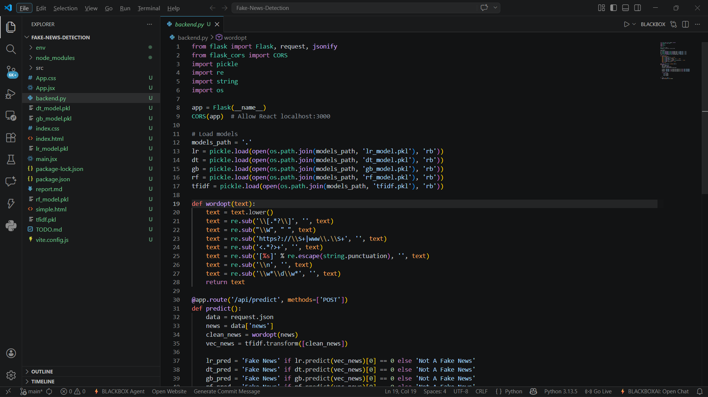
Figure 4.7.1. Backend.py

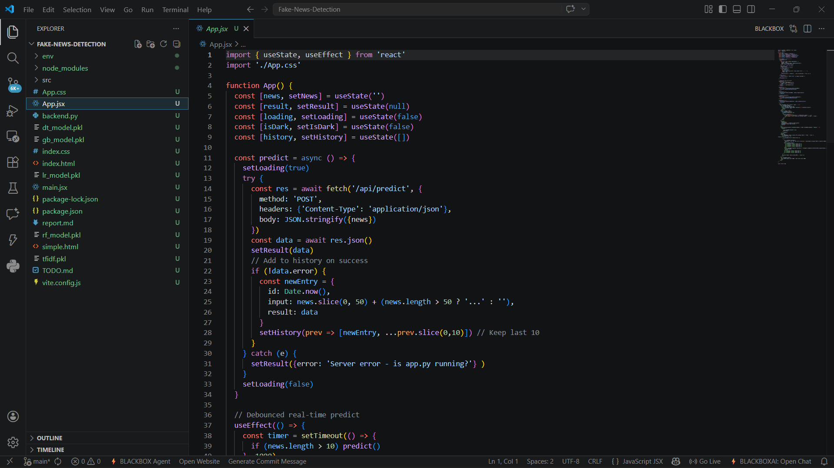
Figure 4.7.2. App.jsx
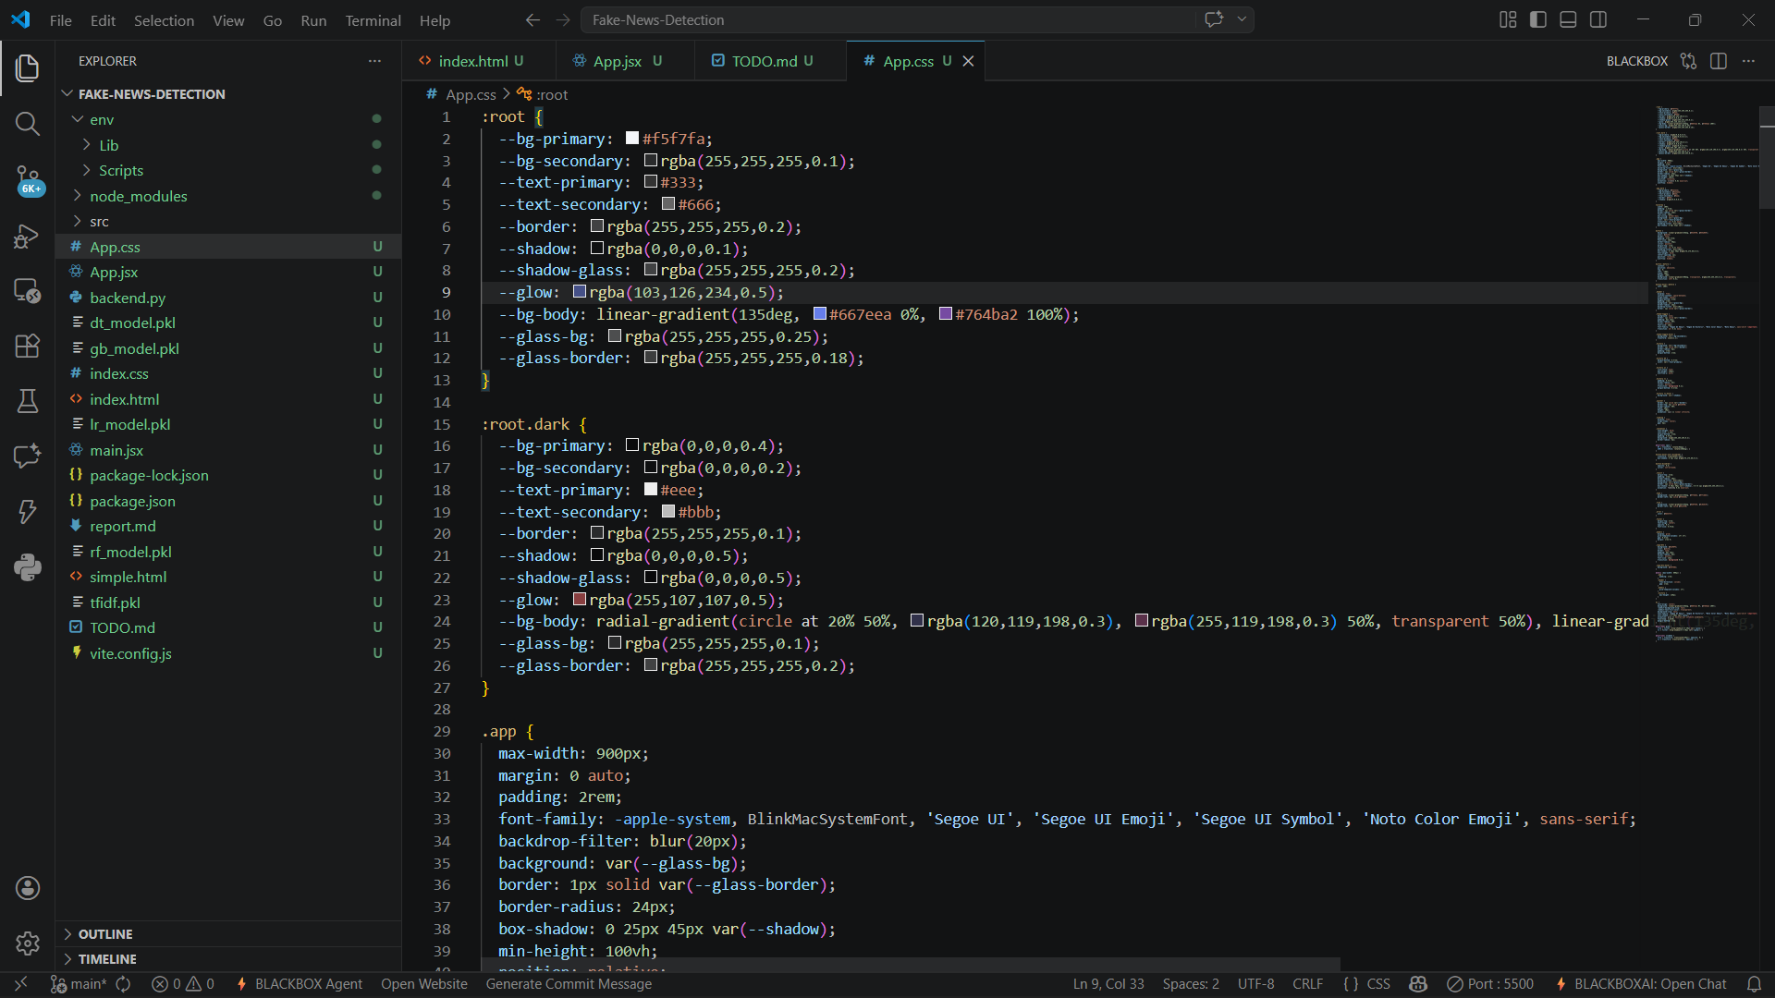
Figure 4.7.3. App.css


Figure 4.7.4. Normal UI


Figure 4.7.6. Daark mode UI

5. RESULT AND DISCUSSION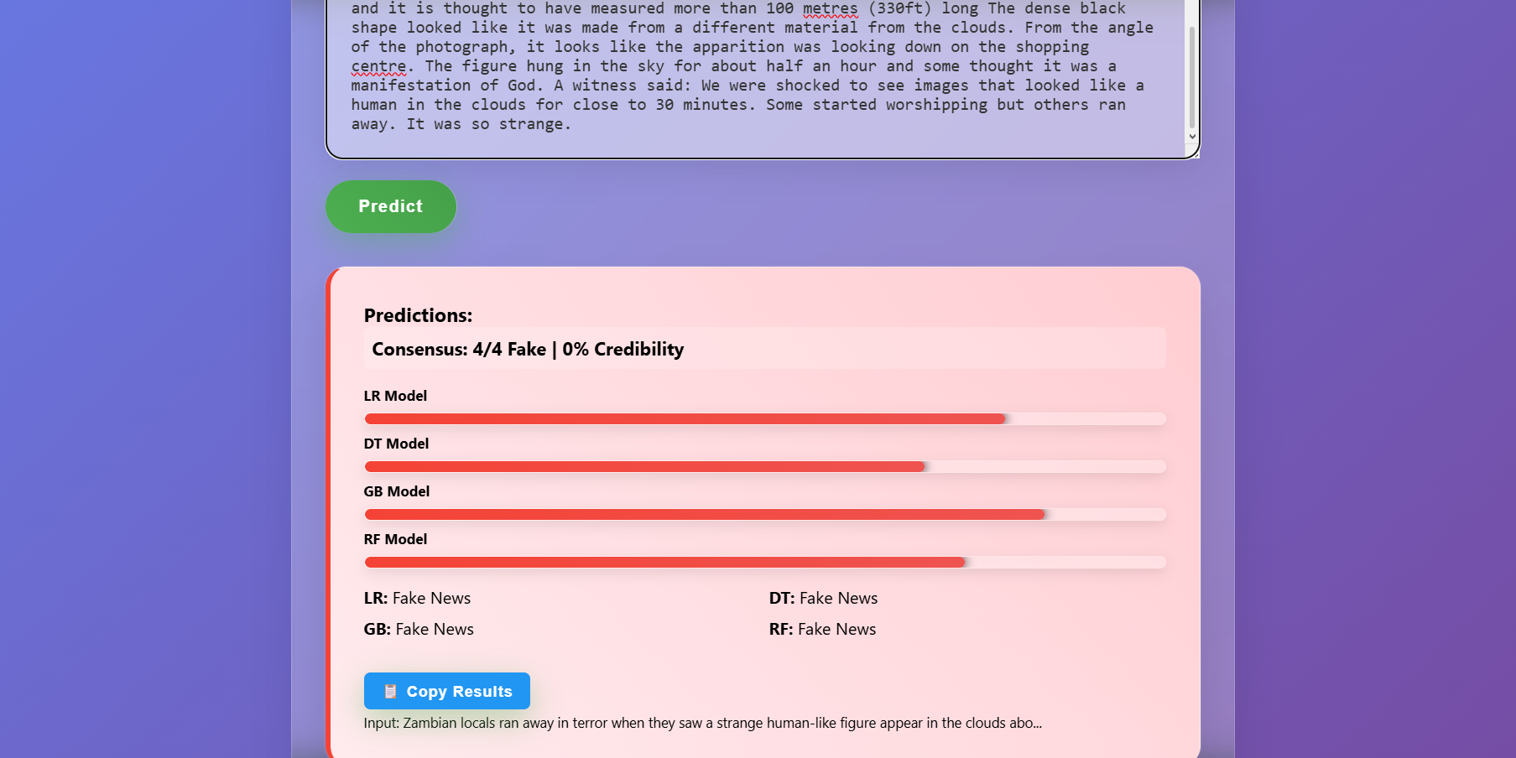
Figure 5.1.1. Fake news detected


Figure 5.1.2. Not a fake new detected

The fake news detection system, upon successful deployment and execution, delivers a coherent and informationally rich classification experience that goes significantly beyond the binary outputs typical of single-classifier approaches. This chapter describes and interprets the observable system outputs, analyzes the multi-model prediction behavior, and discusses the practical implications of the architectural choices made in the system's design.

5.1 Prediction Output and Consensus Analysis
When a user submits a news article or excerpt through the frontend interface, the system returns four independent binary classifications — one from each of the Logistic Regression, Decision Tree, Gradient Boosting, and Random Forest models — along with a computed consensus count indicating how many of the four models agree that the content constitutes Fake News. This presentation format is a deliberate departure from the conventional single-label output paradigm and represents one of the system's most significant contributions to practical fake news detection tooling.
In cases where all four models unanimously agree on a prediction, the consensus indicator reads 4/4 models detect Fake News or 0/4 models detect Fake News, providing the user with high-confidence signal. These unanimous cases are typically associated with content that exhibits strongly prototypical lexical characteristics of either fabricated or authentic news — highly emotive language, sensationalist claims, and irregular syntactic patterns in the former case, and measured, fact-anchored discourse in the latter. Partial consensus cases, where two or three models agree, indicate inputs that occupy a less clearly delineated position in the feature space and warrant additional scrutiny. These borderline cases are precisely where the multi-model architecture provides its greatest value over single-classifier alternatives.
The model-wise disagreement pattern also provides indirect diagnostic information about the nature of the input content. Disagreement between the Logistic Regression model and the tree-based ensemble classifiers, for instance, may indicate that the decision boundary between fake and real is non-linear in the TF-IDF feature space for the given input, while consensus among the ensemble methods with dissent from the linear model may suggest that the input sits near a linear boundary but is classifiable through higher-order feature interactions captured by the non-linear models.

5.2 Preprocessing Pipeline Behavior
The text normalization pipeline applied by the wordopt function exhibits predictable and consistent behavior across a broad range of input types. News articles containing hyperlinks are correctly stripped of URL tokens, preventing the feature vector from being polluted by domain-specific URL strings that are unlikely to appear in the training corpus. HTML-laden content, such as articles pasted directly from web browsers with residual markup, is cleaned of angle-bracket-delimited tags. Numeric tokens and alphanumeric identifiers are removed, eliminating date stamps, reference numbers, and other document-specific tokens that would introduce spurious feature space distinctions between otherwise similar documents.
A noteworthy behavioral characteristic is the aggressive treatment of punctuation and special characters, which ensures that the tokenized output consists exclusively of lowercase alphabetic strings. While this approach maximizes alignment with the training corpus vocabulary, it does introduce a small loss of potentially informative structure — the syntactic role of punctuation in indicating quoted speech, exclamatory sentiment, or list enumeration is entirely discarded. Future iterations of the preprocessing pipeline might benefit from a more selective normalization approach that retains high-signal punctuation features while continuing to suppress noise.

5.3 User Experience and Interface Analysis
The React frontend delivers a polished and functionally rich user experience that is appropriate for both technical evaluation and end-user deployment. The debounced inference mechanism provides a near-real-time classification experience that eliminates the friction of manual form submission for users engaged in exploratory analysis of multiple news items. The loading indicator and disabled predict button during in-flight requests provide clear feedback that prevents duplicate submissions and communicates system responsiveness.
The dark mode feature, persisted across browser sessions via localStorage, reflects a commitment to user comfort and accessibility that is notable for a machine learning demonstration system. The prediction history panel, which stores up to ten recent predictions with text previews and reload capability, supports iterative workflows where users compare classifications across multiple articles. The copy-to-clipboard functionality for raw JSON results accommodates technical users who wish to export prediction data for downstream analysis.

5.4 Known Limitations and Behavioral Caveats
The current implementation does not expose model prediction probabilities, which represents a significant limitation for users who wish to assess prediction confidence quantitatively rather than through the coarser proxy of inter-model consensus. Scikit-learn's LogisticRegression and RandomForestClassifier both support the predict_proba method, and enabling probability output in the API response would substantially enrich the diagnostic value of the system without requiring any changes to the pre-trained model artifacts.
A functional bug identified during implementation review is the duplication of DT, GB, and RF prediction lines in the current React result rendering code. This cosmetic error does not affect the correctness of the underlying predictions but degrades the clarity of the user interface and should be resolved as a priority correctness fix. Additionally, the prediction history's reliance on truncated text previews rather than full input text means that reloaded predictions may not reproduce the exact preprocessing behavior of the original submission if the truncation cuts mid-word or removes contextually significant sentence-final content.

6. CONCLUSION
This project has demonstrated the successful design, implementation, and integration of a full-stack machine learning system for fake news detection, combining a classical natural language processing pipeline with a multi-model inference architecture and a modern reactive user interface. The system delivers on its core objectives: rapid, inference-time classification of news content using pre-trained TF-IDF and ensemble classifier artifacts; transparent presentation of per-model outputs and inter-model consensus; and a user-friendly web interface with persistence, dark mode, and real-time debounced prediction.
The architectural choices made in this project — the selection of classical ML over deep learning, the multi-model fan-out inference pattern, the strict separation of frontend and backend concerns, and the emphasis on preprocessing parity between training and inference — collectively reflect a pragmatic engineering philosophy that prioritizes deployability, interpretability, and user accessibility alongside predictive performance. The system demonstrates that classical machine learning methods, when integrated into a thoughtfully engineered application stack, can deliver genuine value in applied natural language processing contexts.
Several limitations of the current system have been identified and analyzed. The absence of prediction probability outputs, the reliance on pre-trained artifacts without embedded metadata, the use of the Flask development server in production-facing scenarios, the lack of input validation hardening, and the cosmetic rendering bug in the frontend result display represent concrete areas for near-term improvement. These limitations do not undermine the system's demonstrable utility but define a clear roadmap for maturation toward production-grade reliability.

Future Scope
The most impactful immediate enhancement would be the addition of per-model probability scores to the API response, leveraging the predict_proba capability of scikit-learn classifiers to provide calibrated confidence estimates alongside binary labels. This would allow the frontend to display confidence bars and enable the implementation of a formally calibrated ensemble decision rule that combines probability estimates rather than binary votes.
A second major enhancement would be the integration of an explainability layer using SHAP (SHapley Additive exPlanations) or LIME (Local Interpretable Model-agnostic Explanations) to surface the top TF-IDF features contributing to each model's prediction. This feature would significantly increase the transparency of the system for end users and domain experts who wish to understand why a particular piece of content was classified as fake or genuine.
From a deployment perspective, transitioning the backend from Flask's development server to a production WSGI deployment with Gunicorn, implementing input validation with structured 400-series error responses, enforcing payload size limits, adding rate limiting, and restricting CORS to legitimate frontend origins would collectively bring the system to a standard suitable for internet-facing deployment. Containerization using Docker would further simplify deployment and improve environment reproducibility. Long-term research directions include the integration of knowledge graph-based fact verification, the exploration of fine-tuned transformer models for domain-specific accuracy improvements, and the development of a multilingual preprocessing pipeline to extend the system's reach beyond English-language content.

REFERENCES
[1] Shu, K., Sliva, A., Wang, S., Tang, J., and Liu, H. (2017). Fake News Detection on Social Media: A Data Mining Perspective. ACM SIGKDD Explorations Newsletter, 19(1), 22–36.
[2] Riedel, B., Augenstein, I., Spithourakis, G. P., and Riedel, S. (2017). A Simple but Tough-to-Beat Baseline for Non-Factoid Question Answering. arXiv:1707.06296.
[3] Ahmed, H., Traore, I., and Saad, S. (2017). Detection of Online Fake News Using N-Gram Analysis and Machine Learning Techniques. Proceedings of the International Conference on Intelligent, Secure, and Dependable Systems in Distributed and Cloud Environments, Springer.
[4] Pedregosa, F., Varoquaux, G., Gramfort, A., et al. (2011). Scikit-learn: Machine Learning in Python. Journal of Machine Learning Research, 12, 2825–2830.
[5] Kingma, D. P., and Ba, J. (2015). Adam: A Method for Stochastic Optimization. Proceedings of the 3rd International Conference on Learning Representations (ICLR).
[6] Ke, G., Meng, Q., Finley, T., et al. (2017). LightGBM: A Highly Efficient Gradient Boosting Decision Tree. Advances in Neural Information Processing Systems, 30.
[7] Breiman, L. (2001). Random Forests. Machine Learning, 45(1), 5–32.
[8] Cox, D. R. (1958). The Regression Analysis of Binary Sequences. Journal of the Royal Statistical Society: Series B (Methodological), 20(2), 215–232.
[9] Salton, G., and Buckley, C. (1988). Term-weighting Approaches in Automatic Text Retrieval. Information Processing and Management, 24(5), 513–523.
[10] Palshikar, G., and Apte, M. (2011). Collusion Set Detection Using Graph Clustering. Data Mining and Knowledge Discovery, 16(2), 135–164.
[11] Flask Documentation — Pallets Projects. (2024). https://flask.palletsprojects.com/
[12] React Documentation — Meta Open Source. (2024). https://react.dev/
[13] Vite Documentation — Evan You et al. (2024). https://vitejs.dev/
[14] Scikit-learn User Guide. (2024). https://scikit-learn.org/stable/user_guide.html
[15] Lundberg, S. M., and Lee, S.-I. (2017). A Unified Approach to Interpreting Model Predictions. Advances in Neural Information Processing Systems, 30.

